## Quiz: Step-over and step-into

Quiz link: [Quiz: Step-over and step-into | Watch and Code](https://watchandcode.com/courses/350615/lectures/22914102)

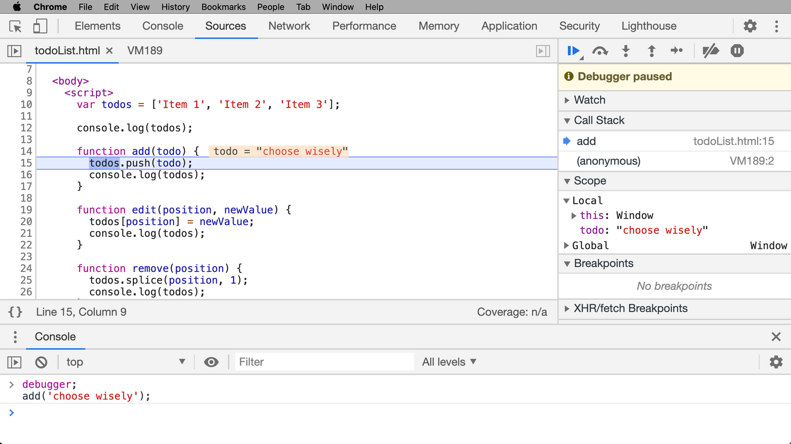My screen currently looks like this. What will happen after I hit "Step-over" and then "Step-into"?

1. The debugger will be paused at line 15
   1. False – 100%, The debugger did not stop at line 15.
2. The debugger will be paused at line 16
   1. False – 100%, The debugger did not stop at line 15.
3. The debugger will be paused at line 17
   1. True – 100%, The debugger stopped here.
4. None of the above
   1. False – 100%, There is a valid answer.